Marginal Benefit Analysis for Leak Detection Systems

*Abstract: this paper provides a suggested approach to measuring the realized benefit of leak detection systems. The methodology highlights leak detection’s role in oil spill response; detecting a leak will effectively decrease the size of the oil spill. Quantifying this information will be useful in ranking projects by their ability to reduce the environmental, economic and socio-economic risks of an oil spill.*

**Introduction**

Leak detection systems have been developed and installed with a heavy focus on performance requirements. This is especially true for TAPS because the state regulation specifies that TAPS’ leak detection must be installed that can detect a leak no greater than one percent of daily throughput. Although the detection limits of a leak detection system are an important technical specification this regulatory requirement does not attempt to measure how much the leak detection system(s) reduce the environmental, socio-economic and oil response costs of an oil spill. Without performing an analysis on the impact leak detection systems have on reducing the risks/magnitudes of oil spills it is impossible to determine how effective the system is at accomplishing its core purpose.

Leak detection is a critical component of oil spill response in that it has the potential to reduce the time between the onset of a leak and the response thereby decreasing the total spill volume. While there are many variables— location, oil type and cleanup strategy—that impact the cost of an oil spill the total spill volume is a critical factor. The benefit of a leak detection system can be expressed as follows: leak detection benefit = oil spill cost without the system – oil spill cost with the system. Measuring these costs is not trivial and this paper suggests a methodology to accomplish this task.

**Estimating the Cost of an Oil Spill at Numerous Locations**

In order to measure the impact of a leak detection system, the cost of an oil spill as a function of spill size should be computed at numerous locations along TAPS. There are many ways to estimate the cost of an oil spill. The two suggested approaches are to estimate the costs using a qualitative analysis and/or to develop a cost estimation model. Performing a qualitative analysis will not clearly communicate key assumptions made while determining costs it can be it can be create an awareness of oil spill costs. This analysis can be done in a similar fashion to evaluating process risks using a process hazard analysis. Developing an accurate cost estimation model is difficult but there has been a lot of work on this effort on behalf on the EPA and other public organizations. The suggested approach is to use a modified version of the EPA Basic Oil Spill Cost Estimation Model (BOSCEM). This model breaks down all of the factors that contribute to the cost of an oil spill.

A PHA-style quantitative analysis can be used to estimate the cost of an oil spill. The accuracy of this analysis will heavily depend on the experience of the individuals that contribute to it. It is suggested that the following expertise be present during the analysis: law, pipeline hydraulics, civil engineering, public relations, biology, integrity management and economics. During the meeting these individuals will estimate the cost of various spill sizes while considering the internal and external costs of an oil spill namely cost of cleanup, lawsuits, fines, lost product, public relations and economic impact.

|  |  |  |  |  |  |
| --- | --- | --- | --- | --- | --- |
| **Table 1: Form Used to Assist in Qualitative Analysis** | | | | | |
| **Milepost** |  | | **Date** | |  |
| **Oil Spill Cost** | | | | | |
| Spill Size (BBL) | | Approximate Cost (2013 USD) | | Marginal Cost (2013 USD) | |
| 1 or Less | |  | | N/A | |
| 10 | |  | |  | |
| 100 | |  | |  | |
| 1,000 | |  | |  | |
| 10,000 | |  | |  | |
| 100,000 | |  | |  | |
| 1,000,000 or Greater | |  | |  | |

BOSCEM was developed to provide the US Environmental Protection Agency Program with a methodology for estimating oil spill costs. The model parameters are based on hypothetical spills in Etkin *et al.* (2002, 2003) with oil fate modeling by Applied Science Associates’ SIMAP in French-McCay *et al.* 2002. These parameters can be adjusted to accommodate the socio-economic, environmental and oil response costs along the TAPS right of way. Below is a brief description of BOSCEM (Etkin, 2004). This version of BOSCEM considers three separate contributions to the total oil spill cost: spill response, socio-economic and environmental.

$$C_{total}=C_{R}+C_{S}+C_{E}$$

Where the spill response cost (CR ), socio-economic cost (CS ) and environmental cost (CE ) are given below:

$$C_{R}={\overline{c}}_{R}\left(V,OilType\right)α_{R}\left(AreaType\right)V$$

$$C_{S}={\overline{c}}_{S}(V,OilType)α_{S}(AreaType)V$$

$$C_{E}={\overline{c}}_{E}(V,OilType)\frac{1}{2}(α_{E}\left(AreaType\right)+β_{E}\left(AreaType\right))V$$

In the event that there is a spill that covers multiple area types calculate the cost associated with each area type individually and then aggregate the costs. Suggested values for the per volume cost ( $\overline{c}$), and multipliers (α, β) are given in Appendix A. This model could be used to develop a cost curve based on oil spill size for multiple locations along the pipeline. It may also be useful to consider the cost of lost production which would require an estimate of the time that the pipeline would be shut down during and after an oil leak that is directly attributed to the oil spill itself (and not equipment damage). This modeled cost needs to be tied back to the leak from the pipe itself. There are many methods with varying levels of sophistication that can be used to estimate the oil spill characteristics associated with a pipeline leak the method chosen should at least consider the soil porosity, topography and whether the pipe is above or below ground.

**Leak Detection System Performance**

In order to measure the realized benefit of leak detection systems it is important to recognize how they add value; leak detection systems add value by reducing the cost of an oil spill by decreasing the oil spill size. After an onset of a leak there are the following contributions to the amount of time it takes to respond. A possible formulation of this time period is the time it requires to detect the leak and the time it requires to physically respond to the leak. There are two types of response to an oil spill: cleanup/containment and operating changes. Both of these responses should be considered because they affect the oil spill cost in different ways; operating changes can impact the size of the oil spill and cleanup and containment can reduce the spread of the oil spill.

It is useful to consider leak detection performance in terms of a probability distribution of the time it takes for a pipeline controller to detect a leak versus the leak size and location and the probability that the controller will be able to detect a leak versus the leak size. For systems that automatically alarm the two components of this time period is the time it takes for the system to generate an alarm and the time it will require for the controller to respond to the alarm while the two components of the probability that the controller will detect a leak is the probability that the system will alarm in the event of a leak and the probability that the controller will diagnose the alarm correctly.

$$p_{detect}\left(Q\right)=p_{alarm}\left(Q\right)*p_{response}(Q)$$

$$t_{detect}=t_{alarm}+t_{response}$$

Estimating the probability distribution for the time to alarm for most leak detection systems is pretty straight forward. Here is an example of how the time to detect and probability can be displayed:

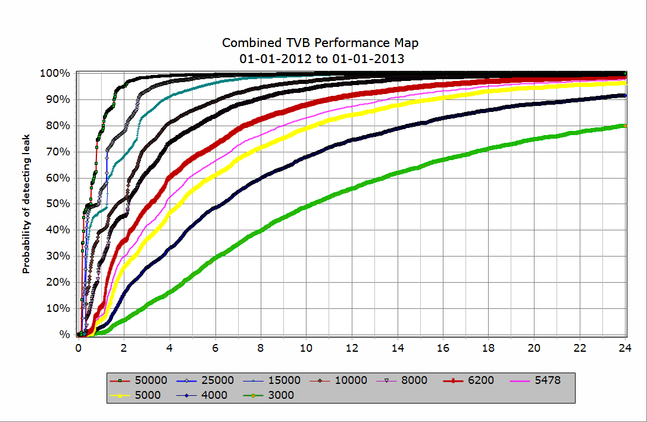

Figure 1: TVB performance map. This is an example of how a leak detection system’s performance can be expressed in terms of probability and time to detect by leak size

This performance will need to be coupled with the probability of the pipeline controller being able to attribute a leak alarm accurately. After the controller correctly attributes the alarm they will go through a response that will minimize the oil spill. The effect of this action will depend heavily on the location but in general taking action will reduce the total spill volume. The spill volume after action is taken should be estimated and added to the spill volume that accumulated during the time period required for the leak detection system to alarm and controller response.

$$V_{spill}=Qt_{alarm}+Qt_{response}+V_{post-response}$$

In reality there are multiple leak detection systems monitoring TAPS. There are multiple CPM technologies, internally controlled Ariel Surveillance, external Ariel Surveillance, security cameras, visual observation, satellite imagery etc. Each of these systems has a probability of detecting the leak based on leak rate, location and/or spill volume. In order to accurately assess the benefit of a leak detection system each system must be analyzed alongside currently installed systems. This will require that an estimate of the performance of each of these systems be completed.

For many leak detection systems, measuring performance is much less straight forward. In cases where there is not a good understanding of performance a qualitative PHA-style process can be used to make estimations. The collaborative meeting used to estimate the performance for each system will have a very different personnel requirement and their selection should be carefully considered. During this process, it is recommended to structure the discussion around generating data to populate table 2.

|  |  |  |  |
| --- | --- | --- | --- |
| **Table 2: Form Used to Assist in Qualitative System Performance Analysis** | | | |
| **Milepost** |  | **Date** |  |
|  | Detection Success | Time to Detect | |
| Spill Size (BBL) | Probability | Average | Standard Deviation |
| 1 or Less |  |  |  |
| 10 |  |  |  |
| 100 |  |  |  |
| 1,000 |  |  |  |
| 10,000 |  |  |  |
| 100,000 |  |  |  |
| 1,000,000 or Greater |  |  |  |

The Detection Success is the probability that the system will detect an oil spill while the time to detect is the time required to catch the spill in the case that detection is successful. For some leak detection systems such as schedule surveillance it may be useful to collect information shown in table 3 and calculate the data to populate table 2.

|  |  |  |  |
| --- | --- | --- | --- |
| **Table 3: Form Used to Assist in Qualitative System Performance Analysis** | | | |
| **Milepost** |  | **Date** |  |
|  | Detection Success | Frequency | |
| Spill Size (BBL) | Probability | Average | Standard Deviation |
| 1 or Less |  |  |  |
| 10 |  |  |  |
| 100 |  |  |  |
| 1,000 |  |  |  |
| 10,000 |  |  |  |
| 100,000 |  |  |  |
| 1,000,000 or Greater |  |  |  |

The Detection Success in table 3 differs from table 2 in that it is the probability that the scheduled event, which occurs with the specified frequency, will detect an oil spill if it exists.

**Probability of an Oil Leak**

In order to estimate the benefit of a leak detection system there must be a fundamental understanding of the probability of the onset of leaks of different leak sizes. This can be accomplished using a qualitative PHA-style methodology. If this is used it is suggested that the relative probability based on leak size. This can be done by hosting a working session with appropriate individuals to make the estimates required to populate table 4.

|  |  |
| --- | --- |
| **Table 4: Form Used to Assist in Qualitative Relative Probability for Leak Size** | |
| **Date** |  |
| Leak Likelihood | |
| Spill Size (BBL) | Relative Frequency |
| .1 BBL/Hr. or Less | **1** |
| 1 BBL/Hr. |  |
| 10 BBL/Hr. |  |
| 100 BBL/Hr. |  |
| 1,000 BBL/Hr. |  |
| 10,000 BBL/Hr. |  |
| 50,000 BBL/Hr. |  |

One can then leverage the fact that there is a lot of internal information concerning the probability of a leak sized .1BBL/Hr. or less and estimate the expected frequency of larger leak sizes. If it is more convenient the frequency of each leak size can be estimated directly. It may be beneficial to use both methodologies in order to validate the results.

**Stochastic Simulation to Estimate Marginal Benefit of Each Leak Detection System**

Risk is an uncertainty that has a significant cost associated with it and thus it is appropriate to use a stochastic simulation to estimate how risk is reduced by different leak detection systems. In order to measure the marginal benefit of a leak detection system/system enhancement the costs associated with the risk of a pipeline leak should be compared when the targeted system is included in the leak detection system and when it is removed.

$$Marginal Benefit=C_{removed}-C_{included}$$

The simulation will use random numbers and the assigned probability distribution of events to generate the probability distribution of the estimated cost of oil spill cleanup with all leak detection systems in place ($C_{removed}$) and the estimated cost of oil spill cleanup with the targeted system removed ($C_{included}$) over the next n years. Once this methodology is set up the marginal benefit of current systems and potential additional systems and system enhancements can be analyzed.

**Conclusion**

Once there is a mechanism in place to estimate the benefit of leak detection systems and enhancements the suite of leak detection systems can be driven to optimize reducing the environmental, socio-economic and other applicable risks associated with oil spills. This will allow Alyeska to rank leak detection projects by their impact and give management the tools they need to make sound decisions.

APPENDIX A

For data tables See MODELING OIL SPILL RESPONSE AND DAMAGE COSTS, Dagmar Schmidt Etkin, Environmental Research Consulting, Cortlandt Manor, NY, USA